TUESDAY 16 August 2022 “Home at Last”

(Acts 14:26-28)

Hello, my dear 'Walking with Jesus" friends.

When it comes to travel, especially long-distance travel, what is your favorite mode of transportation from one place to another? An automobile, high speed train, ship, airplane, horse drawn carriage or something else?

Let's rejoin Paul and Barnabas, standing on the deck of a cargo sailing ship which likely has a few crew and other passengers. They've left the seacoast town of Attalia on what today would be the southern coast of Turkey and are heading east toward Seleucia and then later on toward Antioch in Syria, which would be about 450 miles north of Jerusalem. Opinions vary on exact dates, but it is likely late in the fall of 46ad or the spring of 47ad. These two men have been on a remarkable journey and here's a good map to help you trace their steps:

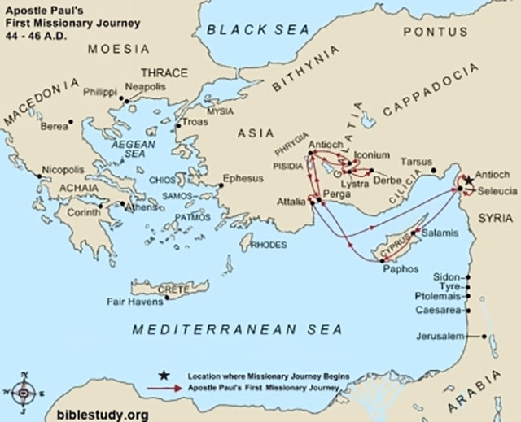

Dr. Luke the physician, and the author of the book of Acts, gives us the amazing story from the time of Jesus' resurrection and ascension, through the subsequent 30 years or so and the remarkable spread of the Gospel by the apostles to the entire Roman Empire. Of course, it would have required multiple volumes to trace the steps of all those who had been disciples of Jesus and were then called apostles, as well as tell the story of Barnabas and Paul. Each of these men understood the commissioning of Jesus clearly. One of the last things Jesus had said to His disciples in Jerusalem before He left them and ascended back to heaven was: "The Holy Spirit will come upon you in power and you will be My witnesses in Jerusalem, Judea, Samaria and to the ends of the earth." (Acts 1:8)

Once in Galilee, Jesus had said to His disciples: "Go into all the world and make disciples, teaching them to obey all that I have commanded you and baptizing them in the name of the Father and the Son and the Holy Spirit." (Matt. 28:19,20) So these men who had 'walked with Jesus' knew exactly what they were supposed to do with the rest of their lives, after Jesus left them and returned to heaven, and that the Holy Spirit would empower them, teaching them and guiding them in HOW and WHERE to do it! For Paul, who as you recall was the Pharisee Saul who had a life changing encounter with the risen Jesus on his way to Damascus where he intended to persecute Christ followers in hopes of eliminating this radical Jesus movement... Saul had become Paul the radical evangelist by the work of the Holy Spirit in His life! Paul had received his personal commissioning from Jesus and understood his life identity and mission was: "You are My chosen instrument to carry My name before the Gentiles and their kings and before the people of Israel." (Acts 9:15)

Recently we've been traveling with Paul and Barnabas on this Paul's first, adventurous 'missionary journey' and yesterday I left you standing on the deck of a sailing ship, with the wind blowing through their hair as they looked east anticipating the great joy of returning to Syrian Antioch. There they would try to recount this remarkable adventure to those who had sent them off nearly two years ago! As the shoreline of Seleucia approaches and their ship begins to drop sails edging closer and closer to the docks, can you sense their excitement? Perhaps they even give each other a big bear hug, oh they can hardly contain themselves as they think about telling their story! Down the gangplank they go, turning to look out over the sea west toward Cyprus Island and remembering how it all had begun so many months ago. Then Paul and Barnabas sling their bags over their shoulders and head toward Antioch, only 15 or 20 miles up the road.

Other travelers are on the same busy road of course, and I can see Paul and Barnabas engaging anyone who will listen as they tell them about the places far away where they've been... Pisidian Antioch, Iconium, Lystra, Derbe! And of course, the question always comes...'why did you travel that far? Do you have business or family there?'

Oh, a big smile would come across their faces and then the words, 'well, since you asked, we have had a remarkable, wonderful, life changing adventure. As we walk along, we'd love to tell you about it..." I wonder how many travelers on that road to Antioch heard the story, and then the Gospel, and then trusted in Jesus to be their Savior?

Dr. Luke then writes these historic words: "On arriving there [Syrian Antioch] Paul and Barnabas gathered the church together and reported all that God had done through them and how God had opened the doors of faith to the Gentiles!" (Acts 14:27) Friends, I doubt we can imagine the 'welcome home' these two men received. It's safe to say their gatherings together of the Antioch Christians to give their report were many, many meetings, each probably lasting hours. So many stories to tell!! How often did the people interrupt their reports by bursting into clapping and shouting their celebration of what Jesus had done in the regions far away of Pamphylia and Pisidia and Galatia? How many times did Paul stop, hoarse, unable to speak, and whisper to Barnabas... 'you take over and continue the story'!? Can you see the people, probably hundreds of them, sitting wide eyed, listening, smiling, clapping, shouting their exuberance and praising God for all HE had done among the Gentiles? Of course, Paul and Barnabas had no photos to show, but I wonder if they brought back any little things from each town which were tangible reminders for them, of those places?
Of course, when they told the story of the riot and stoning in Lystra, Barnabas probably said, 'Go ahead Paul, show them the scars on your arms and legs, and those spots on your head where the hair has not grown back but your skull was cracked open." As Paul did so he of course shook his head saying... "I've had the great privilege of suffering for my Lord! He healed me, to God be the glory!"

Yes friends, we can imagine there was great celebration as Paul and Barnabas told their stories in Syrian Antioch where it had all started. In fairness though we must imagine there were questions, lots and lots of questions about what the Holy Spirit of God was doing in faraway places of the Roman Empire, among pagans and heathens? And for that reason, Luke gives us this closing statement on this first great journey of Paul's..."Paul and Barnabas stayed a long time with the disciples in Antioch." (Acts 14:28) That long time was actually about two years (ad48 & 49). We presume they resumed what they had been doing before they left... teaching the great truths of the Christian faith to those in Antioch who had trusted Jesus and wanted to learn all they could about being followers of Jesus!

Remember, the New Testament had not yet been written, so it was these stories from the apostles about Jesus and the teachings they were learning from the Holy Spirit which was the spiritual nourishment these Jesus followers longed to hear. Oh, they had such an appetite to learn and to grow in their knowledge and understanding of these exciting truths about being a redeemed, regenerated, Holy Spirit filled follower of Jesus. They also hungered to grow in their relationship with Jesus, so Paul and Barnabas taught, and taught and taught.

And Paul did one more thing in those months in Antioch... he began writing. Writing letters which explain what the Holy Spirit was teaching Paul about this wonderful, life transforming Christian faith. He started writing his first letter only a few months after arriving back in Antioch. Tomorrow we'll take a look at why Paul wrote and to whom he wrote. For today... let's just enjoy the celebrations. Let's marvel at all God did through these two men on this remarkable adventure, this first missionary journey, and let's each ask God how He wants to use us to make a difference in our part of the world now, in the rest of 2022, and the rest of our lives!

And here's a song that had it been written then, they certainly would have been singing during those celebrations... oh my it's a powerful song celebrating the person and power of Jesus.

Today's Scripture is Acts 14:26-28.

