THURSDAY 14 July 2022 “Peter Miracles?” (Acts 9:32-43)

Good morning my "Walking with Jesus" friends,

When was the last time the region of the world where you live could be described as 'living in a time of peace'? I don't mean the absence of war but rather a time when all aspects of life were 'peaceful'? In our ongoing journey with the apostles of Jesus in the months and years following His crucifixion, resurrection and ascension back to heaven, yesterday we watched as Saul, the radical Pharisee transformed by the power of the Holy Spirit, left Jerusalem and headed to Tarsus his hometown more than 500 miles from Jerusalem. Saul left, in part, for his own safety, as the reaction was becoming violent to his transformation from being the man leading the opposition to the Jesus movement, to now being the man fully supporting that movement!

Not only did things settle down in Jerusalem but the record gives us this assessment: "Then the church throughout Judea, Galilee and Samaria enjoyed a time of peace and was strengthened. Living in the fear of the Lord and encouraged by the Holy Spirit, the church increased in numbers." (Acts 9:31) As you may know Judea, Galilee and Samaria are the three provinces at that time of the nation of Israel. Judea was the area around the city of Jerusalem and stretching south. Galilee, as you remember, was the area of north Israel where Jesus grew up in Nazareth and spent much of His ministry years. Samaria was the region between Judea and Galilee and as we saw in Acts 8 with the courage of Philip, one of the seven deacons, a great spiritual movement was sweeping through Samaria as even Samaritans were trusting in Jesus and being accepted by Jewish Jesus followers.

We don't know exactly how long this peaceful time lasted, but it must have been a very welcome change from the season of persecution which Saul had led in Jerusalem that we saw in Acts 7&8. Did you notice that once again Luke uses the word 'the church' to describe all the followers of Jesus regardless of where they lived or their gender or their ethnicity! You'll remember 'church' is the English translation of the Greek word "Ekklesia" which means "people called out to God."

The book of Acts, my friends, is not an exact chronology and rarely does it identify dates or times of events, so we don't really know how long this peaceful season lasted. What we do know is that some very significant things happened during this peaceful season in the ongoing story of what the Holy Spirit of God was doing through the apostles as they continued to tell the story of Jesus and teach His truth in the region. Acts 9:32 says: "As Peter traveled about the country, he went to visit the Jesus followers who lived in Lydda. There he found a man named Aeneas, who was paralyzed and had been bed-ridden for eight years." If you visit Israel today, Lydda is a small town just west of the road going north from Jerusalem. In the first century Lydda was about 20 miles from Jerusalem.
Medical care was not at all then what it is today and therefore illnesses and accidents left many more people struggling with medical issues and needing care which simply wasn't available then. We don't know what caused this man's paralysis, but being bed ridden he was entirely dependent on the help of others for every aspect of living. Have you ever been so sick you couldn't get out of bed? How long did that last for you? Can you imagine 8 years like that?

For some reason this man's condition caught the attention of Peter and his heart was deeply touched. I wonder if when Peter saw Aeneas, he remembered another paralyzed man he had met near the gate going up to the Temple. We don't know that man's name, but you may recall his healing turned Jerusalem upside down and resulted in Peter's arrest! (Acts 4) Evidently the Holy Spirit of God once again stirred deeply in Peter's heart when he heard Aeneas' story, he went to visit this paralyzed man. The record says: "Peter said to him, 'Aeneas, Jesus Christ heals you. Get up and roll up your mat." (Acts 9:34) Remember my friends, the book of Acts is written by a physician named Dr. Luke. He was not an eyewitness to this since he didn't hear about Jesus until a few years later when he became a traveling physician with the apostle Paul. So, can you imagine Luke's effort to interview Peter and anyone else who was an eyewitness to this miracle? Luke writes: "Immediately Aeneas got up. All those who lived in Lydda and the nearby town of Sharon saw him and turned to the Lord Jesus." (Acts 9:35)

My friends, do you see what God was doing in these months and first years after Jesus left the apostles to spread His message without Him physically present with them? By the power and guidance of the Holy Spirit the story of Jesus was validated by what Luke calls "signs, wonders and miracles." Acts 2-9 have thus far shown us many examples in Jerusalem, Samaria, Damascus, the road going down to Gaza, and now here in Lydda. People weren't arguing theology nor were they disregarding the apostles as religious fanatics. Rather, people were listening intently to what they said, watching closely the evidence of the Holy Spirit at work in all types of people, and thousands of people were turning to Jesus to be their Savior and Lord. The Holy Spirit was changing entire cities and towns all across Israel as He transformed people into Spirit filled followers of Jesus. May I ask... what is the Holy Spirit doing in your city in July of 2022?

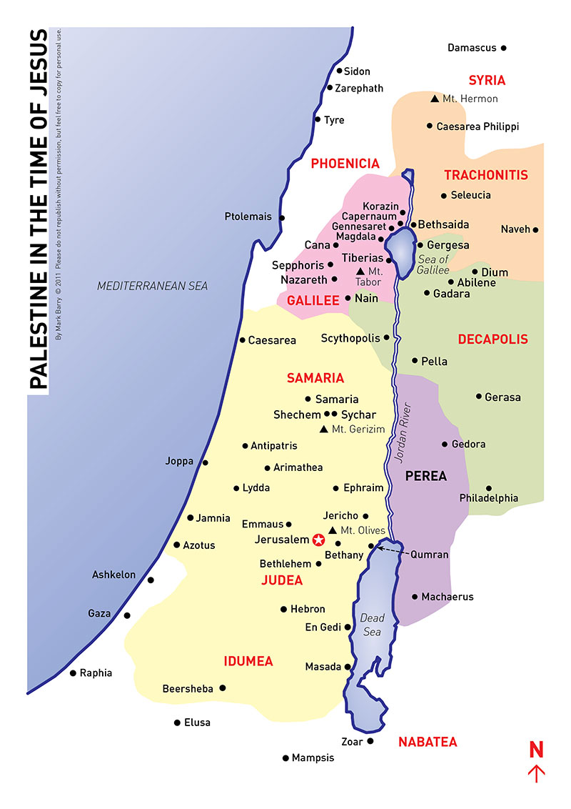
If you continue to read Acts 9 another remarkable event occurs in the town of Joppa which was a coastal town about 20 miles from Lydda. Evidently a dear lady named Tabitha lived in that town and had a reputation of "...always doing good and helping the poor." (Acts 9:36) That stirs my heart. We all have a reputation, don't we? So, what's yours? Sadly, Tabitha became ill, and with only poor medical care available, she died. Evidently some Jesus followers in her town heard Peter was in Lydda only 20 miles away so they sent word to him to come quickly. Upon his arrival the house where her body was laid had already attracted many mourners, including widows and others whom Tabitha had helped by her kindness. I imagine it was not easy for Luke the physician to write the account of what happened next: "Peter got down on his knees and prayed. Turning toward the dead woman he said, 'Tabitha, get up.' She opened her eyes and seeing Peter she sat up. Peter took her by the hand and helped her to her feet. Then he called for the Jesus followers, especially the widows, and presented Tabitha to them, alive. This became known all over Joppa and many people believed in the Lord Jesus." (Acts 9:42)

Now my friends, let me ask you. What was God accomplishing in those days through these miracles? This wasn't about Peter and his fame or fortune or popularity or power, was it? Just as God had been doing powerful things through Philip in Samaria, now God was doing powerful things through Peter in Lydda and Joppa. And do you notice the result was the same both in Samaria and these two towns. Many people turned their lives over to Jesus, fully trusting the truth they were hearing about Jesus from those who had been with Jesus, His apostles.

May I show you one more very interesting thing? Can you imagine how very quickly Peter became a hero here in Joppa and Lydda? Joppa was a busy, important, wealthy, coastal, harbor town. Do you remember Jonah had boarded a ship there running from God? (Jonah 1) I imagine there were many hotels and probably many wealthy import/export merchants and other wealthy businesspeople who had estates high on the cliffs overlooking this beautiful harbor. I wonder how many of them sent for Peter, inviting the miracle worker to come stay as a guest in their estate or hotel? But this wasn't about Peter and Peter knew the danger of allowing his pride to draw the attention to himself rather than pointing people to Jesus. So, Luke gives us this little statement that might seem insignificant, but I think gives us a good look into Peter's heart: "Peter stayed in Joppa for some time with a tanner named Simon." (Acts 9:43)

Tanners' work is hard, smelly, ugly work. The slaughter of animals, the skinning of dead animal bodies, the curing of their hides for making a wide variety of finished products. Old Testament laws warned good Jews to keep far away from anything dead... human or animal. Dead bodies were to be buried or burned quickly and then those people who had touched those bodies had certain purification rights to go through. But this man made his living with dead animal bodies and for good Jewish Peter, he should keep far away from this man and his death business! So why would Peter actually choose to go to his house and stay with him? The Scripture doesn't tell us, but I think it was an intentional choice, guided by the Holy Spirit for two reasons. First to keep Peter humble.
Second, to keep away the crowds and especially those who might try to manipulate Peter for special favors. As Simon the Tanner was at work, I suspect Peter was praying and meditating and seeking to know from the Holy Spirit what was next. Perhaps he was also meeting with Jesus followers teaching them more about Jesus but going back to the Tanner's humble home for the night.

What Peter didn't know is a third reason I think the Holy Spirit had him staying with 'the Tanner'. Very soon, some men will come from a distance to Joppa looking for Peter. They don't know Peter, they've never seen him, so have no idea how to find him in such a big city... until they receive the instructions, "Peter is staying with Simon the tanner whose house is by the sea." (Acts 10:6) We'll look at that tomorrow. Do you see how the Holy Spirit was preparing Peter for an even greater adventure, by having him out of the spotlight, staying with a tanner? I wonder what God might be preparing you and me for, my friends? I urge us to spend some time as Peter did, gaining a fresh perspective on what God might be doing all around you right now. And here's a song to help you ponder that. . .

Today's Scripture is Acts 9:32-43.

