WEDNESDAY 06 July 2022 “Azotus”

(Acts 8:39,40; 1 Samuel 5)

Good morning my "Walking with Jesus" friends,

Summertime, at least where I live in the world, is a time for summer travel. Even with gasoline prices higher than I can ever remember, people are traveling by every available means of transportation. I wonder where your travels will lead you this summer.

Yesterday we witnessed an amazing event, about 2000 years ago, somewhere on the road leading south from Jerusalem toward Gaza. A royal chariot was traveling home to the African nation of Ethiopia. In that chariot was one of the most important officials in the Ethiopian government, the man in charge of the entire Ethiopian treasury. Beside him, in that royal chariot, was a simple looking Jewish man named Philip. Philip was experiencing the ride of his life at the invitation of this Ethiopian official who wanted an explanation to something he was reading... the Hebrew scroll of the prophet Isaiah! Together they were digging into one of the most important chapters in our Bible today, Isaiah 53, which, while written by Isaiah about 650 years before Jesus was born, describes in remarkable detail the suffering and crucifixion Jesus experienced in Jerusalem, as He became the God sent atonement sacrifice for the human race!

Yesterday we discussed together Acts 8:31-39 and Dr. Luke's description of this Ethiopian officials' salvation and baptism, as Philip explained the good news of Jesus to him. Then we have this shocking, unexplainable statement in Acts 8:39... "When they came up out of the water, the Spirit of the LORD suddenly took Philip away, and the Ethiopian official did not see him again, but went on his way rejoicing. Philip, however, appeared at Azotus and traveled about preaching the gospel in all the towns until he reached Caesarea." (Acts 8:39,40)

We don't know exactly where on the journey this remarkable event took place, nor can I explain how Philip simply suddenly disappeared from the scene and was 'transported' by God to Azotus, but today, let's try to understand WHY Philip was miraculously brought to Azotus, of all places!? Remember please, Philip had left a great spiritual awakening in Samaria to come to this road south of Jerusalem. It was both radical and remarkable! Samaritans were becoming Holy Spirit filled Jesus followers just as the Jews in Jerusalem had experienced!

Have you noticed God doesn't do anything by mistake or without significance? And did you notice in Acts 8:40, Philip's travels eventually took him from Azotus north to the coastal city of Caesarea, where he settled, eventually married and raised his family of four daughters! About 20 years after this Acts 8:40 experience we next encounter Philip in Caesarea, when the Apostle Paul is traveling back to Jerusalem at the end of his 3rd missionary journey.
The record says: "We reached Caesarea and stayed in the home of Philip the evangelist, one of the Seven. He had four unmarried daughters who prophesied." (Acts 21:8,9)
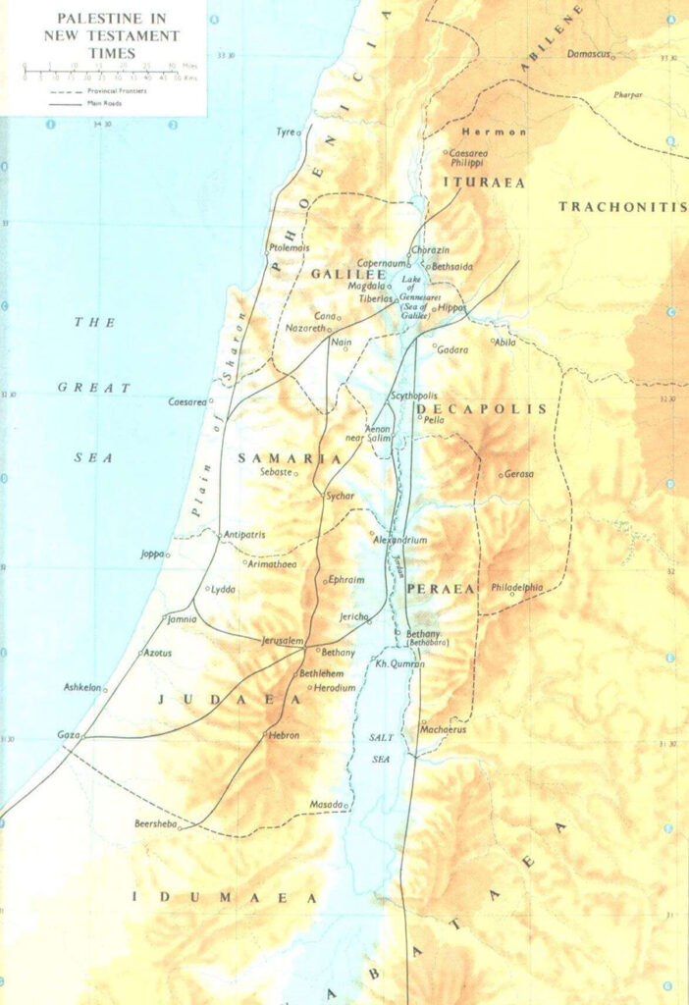

Now back to our question, why did the Holy Spirit take Philip to Azotus? Then as now, every city in the world has a history. This town known as Azotus in the first century was known as Ashdod around 1100bc. At that time, it was one of 5 most significant Philistine cities. The Philistines were enemies of the Israelites. You probably remember the story of David and the Philistine giant Goliath. But do you remember the story of little boy Samuel? In 1 Samuel 4, when Samuel was yet a little boy living at Shiloh where the Hebrew Tabernacle was, the High Priest was Eli. His two sons, the priests Hophni and Phinehas, were wicked, immoral men making a mockery of God and Shiloh, the sacred place of worship. The Philistines attacked the Israelites and Eli's sons did something unthinkable. They took the Ark of the Covenant of God out of the Most Holy Place in the Tabernacle and brought it to the front lines of the battlefield in hopes it would rally the troops and frighten the Philistines. In response God withdrew His protection from the Israelite army and they were soundly defeated, and the Philistines captured the sacred Ark of the Covenant! For the first time since it had been fabricated in the days of Moses at Mount Sinai, the Ark of the Covenant was in enemy hands!

1 Samuel 5 tells us the Philistine warriors brought the Hebrew Ark from the battlefield to their town of Ashdod. And as a supreme act of defilement and mockery of the Hebrew God, they brought the Ark of the Covenant into the temple of their god Dagon and put the Ark right in front of the huge, man-made, statue of Dagon. The symbolism was obvious. The Philistines were making a powerful statement. They had defeated the Israelites on the battlefield and captured their Ark of the Covenant, the most significant symbol of the sacred relationship between God and the Hebrews. Inside that Ark were the two tablets of stone which Moses had brought down from Mount Sinai, on which were inscribed, by the very finger of God, the 10 Commandments. Now, with the Ark sitting at the feet of the statue of Dagon, the Philistines were declaring the supremacy of their god Dagon and the defeat and humiliation of the God of the Hebrews!

Samuel's record tells us the story of God's response to this humiliation. The next morning as the priests of Dagon entered their temple the great statue of Dagon had fallen with its face to the ground in front of the Ark of the Covenant! They put it back in its place. But the following morning Dagon's statue had fallen again, and this time the statue's head and hands had broken off! Soon people started getting sick, very sick, in Ashdod, and in fear the Philistines moved the Ark of the Covenant to another town, and eventually returned the Ark of the Covenant back to the Hebrews. Soon a great spiritual awakening in Israel began under Samuel's humble leadership. Years later this shameful place Ashdod was renamed Azotus, and now 1100 years later, after the defilement of the Ark in Dagon's temple, the Holy Spirit of God brings Philip to this place, after his remarkable salvation and baptism experience with the Ethiopian official. What do you think God was doing, my friends? Why would God bring Philip to Ashdod?
Well, Philip had seen God bring salvation through Jesus and a great spiritual awakening to Jews in Jerusalem, and then to Samaritans in Samaria, and then to an African, Ethiopian official, so why not Ashdod, the ancient Philistine town? God was making another statement of the global supremacy of Jesus Christ, the ONLY Savior of the world!
Once again God was saying the Gospel of Jesus is for EVERY place, EVERY city, EVERY person, and can rescue anyone from their horrible past, no matter what it is! While Luke does not give us details of what happened in Azotus with Philip there, nor how long Philip was there, the closing line of this remarkable chapter 8 of Acts is very significant as we consider all our summer travels in 2022... "Philip traveled about, preaching the Gospel in all the towns, until he reached Caesarea." (Acts 8:40)

If you follow the map north from Azotus to Caesarea, there is one other significant town we can presume Philip visited before arriving in Caesarea. Do you see it? Joppa. That is the ancient city from which Jonah boarded a ship trying to run away from God around 790bc. Seems to me that with both Jonah and Philip God was trying to accomplish the same thing... bring God's message of hope to their world. Jonah ran the other direction, but Philip said YES. Oh, my what a different experience those two men had! By the way the town of Joppa is today a suburb of the great city of Tel Aviv!

So where will your travels take you this summer of 2022 my friends? What will you experience in each place and how will you impact each place you visit? Will God speak to you and guide you in your summer travels? Remember, everywhere your travels take you has both a history and a future, and could it be God is bringing you to those places this summer for something very special both for you and for the people who live there?

Today's Scripture is Acts 8:39-40 & 1 Samuel 5.

